Sidebar Boxes

These instructions cover how to create the sidebar boxes, i.e. those boxes used on the Charter pages to highlight Standards Produced and Previous charters.

1. Create a new Text element in the “Normal” column of the template
2. Type your header and your list of items. If you will have multiple boxes, type the text for all of them.

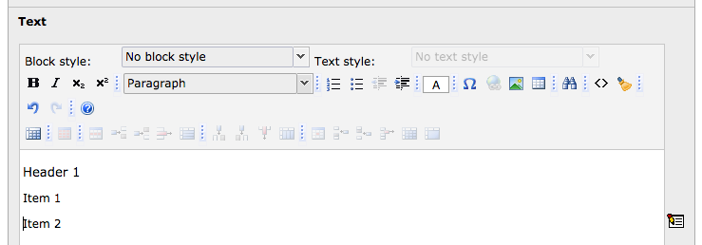

1. Highlight your text and choose “Container” from the block format drop down list

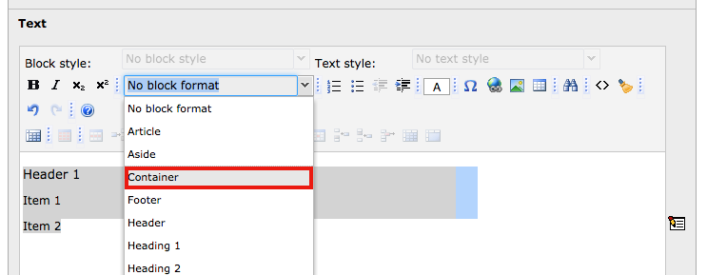

1. With the text still highlighted, choose “Standards: Right sidebar…” from the Block Style drop down list

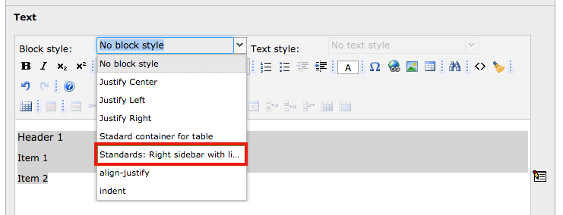

1. Highlight your header text and choose “Heading 2” from the block format drop-down list.

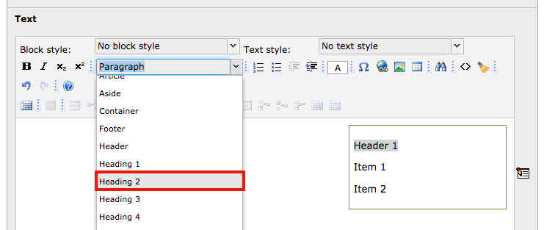

1. Highlight your list items and choose the bulleted list option from the toolbar

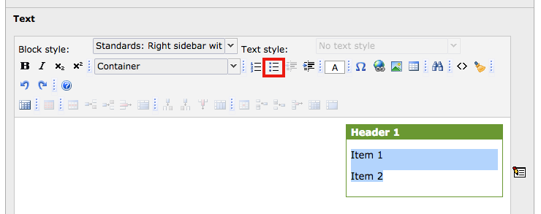

1. Save your changes